**EXPERIMENT – 8**

**Aim:** To implement inter LAN communication using the Cisco packet tracer.

**Theory:**

Inter-LAN communication, short for "Inter-Local Area Network communication," refers to the exchange of data and information between different local area networks (LANs). A LAN is a network of computers and devices that are interconnected within a limited geographic area, such as a home, office, or campus.

Inter-LAN communication allows these separate LANs to communicate and share resources with each other, enabling data transfer and collaboration across different network segments. Inter-LAN communication is crucial for organizations with multiple office locations or complex network setups. It allows for the efficient sharing of resources, data, and services while ensuring security and control over the traffic between LANs.

**Procedure**

1. Open Cisco Packet Tracer and create a new project.
2. Drag and drop 2 switches (type: 2960).
3. Connect 3 PCs to first switch and 2 PCs to second switch.
4. Configure IP addresses of PCs connected to first switch (10.0.0.1, 10.0.0.2 and 10.0.0.3) and PCs connected to second switch (192.168.1.1 and 192.168.1.2).
5. For all PCs in first switch set default gateway to 10.0.0.4 and do the same for PCs connected to second switch to 192.168.0.3.
6. Take a router and connect the two switches to it through GigabitEthernet0/0 and GigabitEthernet0/1 ports of the router.
7. Configure IP addresses of the ports as 10.0.0.4 and 192.168.1.4 respectively. Remember to turn “ON” the Port Status when configuring IP.
8. Now, open the command prompt of any one PC of LAN1 and ping the IP address of any PC of LAN2 to check the connection.

Project Setup

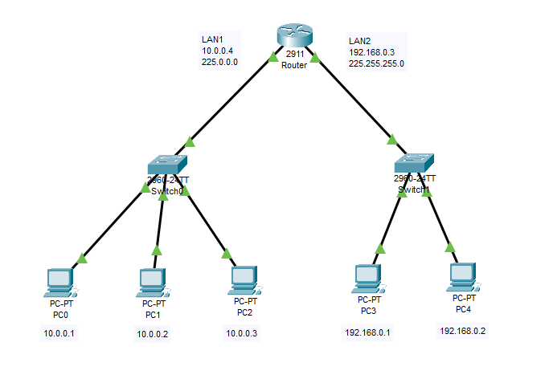

PC Configurations

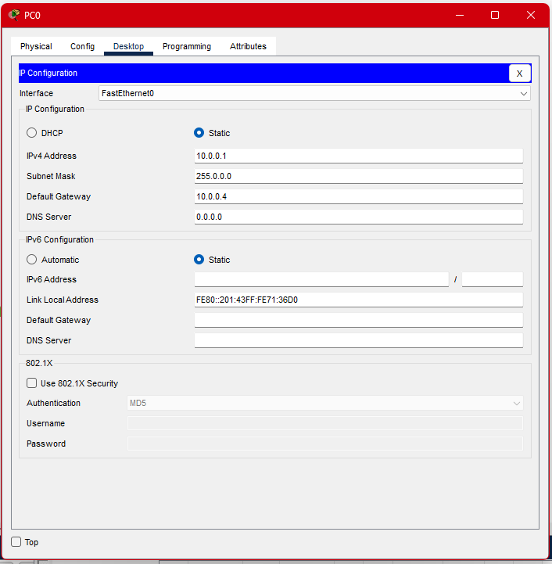

Router Configuration

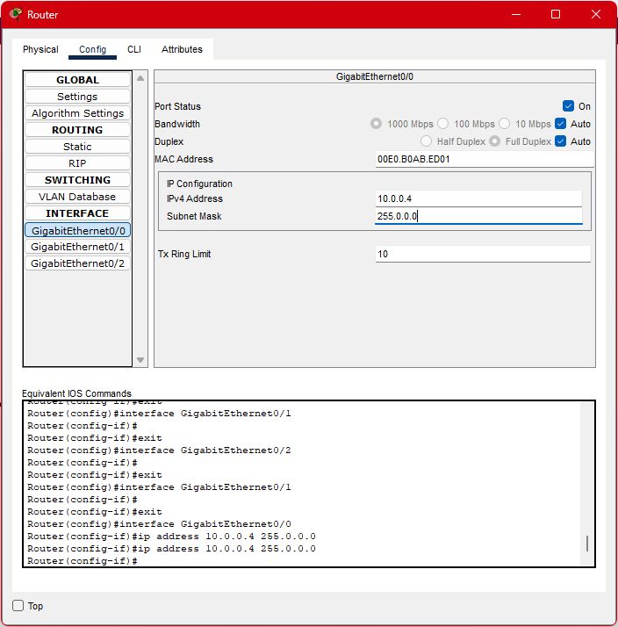

Testing the connection

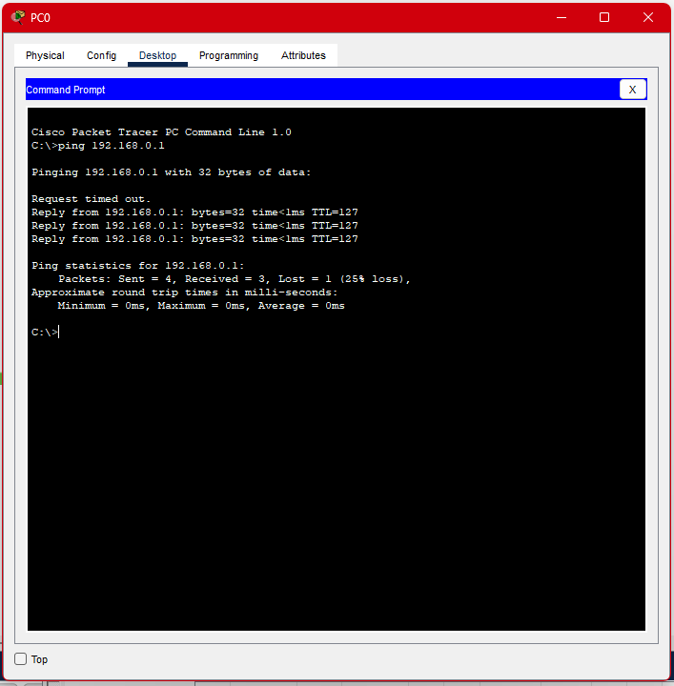

**EXPERIMENT – 9**

**Aim:** To implement the Dynamic Routing Protocols: RIP, EIGRP using Cisco Packet Tracer.

**Theory:**

Routing Information Protocol (RIP) is a dynamic routing protocol that uses hop count as a routing metric to find the best path between the source and the destination network. It is a distance-vector routing protocol and works on the Network layer of the OSI model. RIP uses port number 520.

Hop count is the number of routers occurring in between the source and destination network. The path with the lowest hop count is considered as the best route to reach a network and therefore placed in the routing table. RIP prevents routing loops by limiting the number of hops allowed in a path from source and destination. The maximum hop count allowed for RIP is 15 and a hop count of 16 is considered as network unreachable.

Enhanced Interior Gateway Routing Protocol (EIGRP) is a dynamic routing protocol that is used to find the best path between any two-layer 3 devices to deliver the packet. EIGRP works on network layer Protocol of OSI model and uses protocol number 88. It uses metrics to find out the best path between two layer 3 devices (router or layer 3 switches) operating EIGRP.

To keep routers aware of the state of their neighbors, each router sends out periodic HELLO packets. A router from which no HELLO packet has been received in a certain period of time is assumed to be inoperative.

EIGRP also uses a reliable transport mechanism to guarantee the ordered delivery of all EIGRP packets to its neighbors. The transport supports the intermixed transmission of multicast and unicast packets.

Unlike protocols such as IGRP, EIGRP doesn't rely on the routing table alone to hold the information needed to exchange packets. It also uses the topology table, which stores information advertised by its neighbors about their known routes. The topology table maintains details such as path reliability, total delay, feasible distance and reported distance.

**Procedure:**

1. Open Cisco Packet Tracer and create a new project.
2. Drag and drop 2 switches (type: 2960), 2 Routers (type: PT).
3. Connect 2 PCs to first switch and 2 PCs to second switch.
4. Connect the switches to the routers, Connect the two routers with “Serial” wire.
5. Configure IP addresses of all PCs as shown in setup figure.
6. Add default gateway of 192.168.10.1 to all PCs of first switch and 192.168.20.1 to second switch.
7. Configuring Router:
   1. Go to “Config”, inside the interfaces, select “FastEthernet0/0” and add the IP configurations of the default gateway (192.168.10.1).
   2. In the same section, select “Serial2/0” and add IP address to the external network (10.0.0.1). Also change the clock rate to 64000 (optional).
   3. Go to “CLI”, and add following commands to set:
      1. RIP protocol

Router(config)#router rip

Router(config-router)#network 192.168.10.0

Router(config-router)#network 10.0.0.0

* + 1. EIGRP protocol

Router(config)#router eigrp 10

Router(config-router)#network 192.168.10.0

Router(config-router)#network 10.0.0.0

* 1. Go to “Config”, and in “Global” > “Setting”, under NVRAM select “Save” to update neighboring information.
  2. RIP protocol also has a GUI method, all needed is to add the given networks to the table by writing the network address and pressing “Add”.

1. Repeat the same for the second router, with network addresses 192.168.20.0 and 10.0.0.0.
2. Now, open the command prompt of any one PC of LAN1 and ping the IP address of any PC of LAN2 to check the connection.

Project Setup

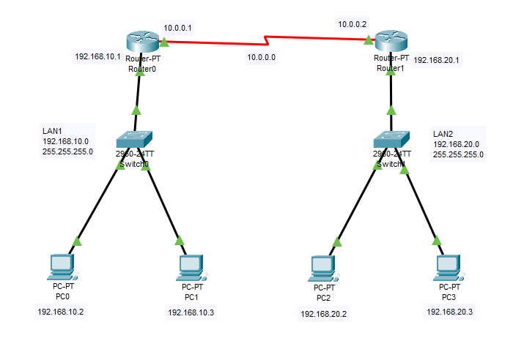

PC Configurations

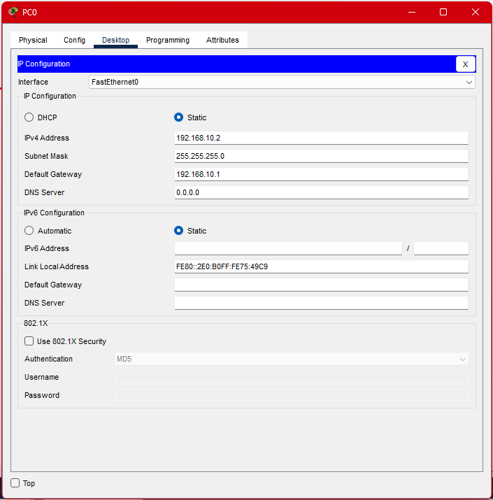

Router Configuration: FastEthernet0/0

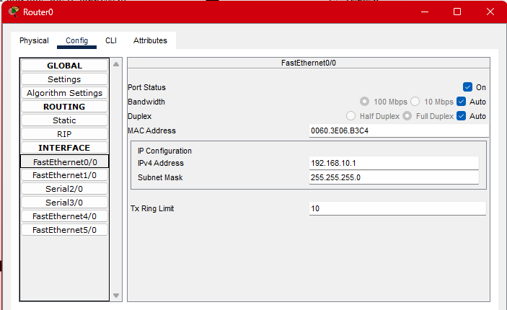

Router Configuration: Serial2/0

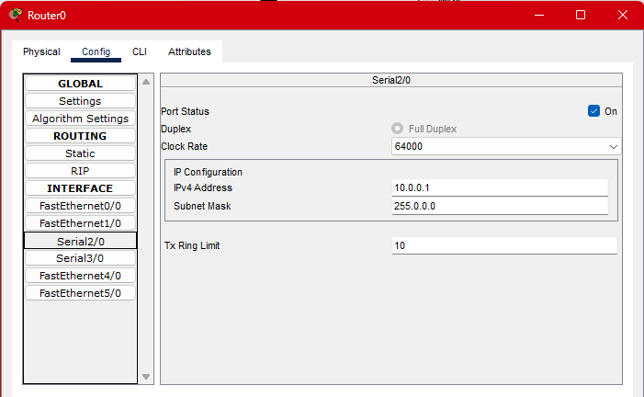

Router Configurations: RIP settings

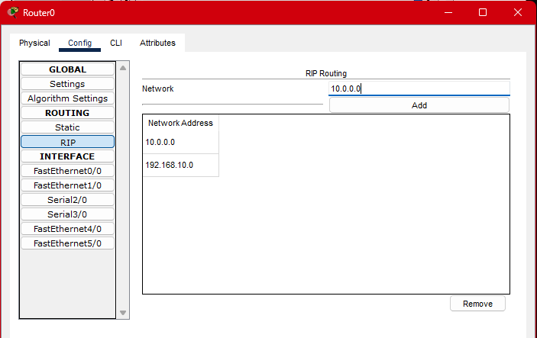

Testing Connection from LAN1 to LAN2

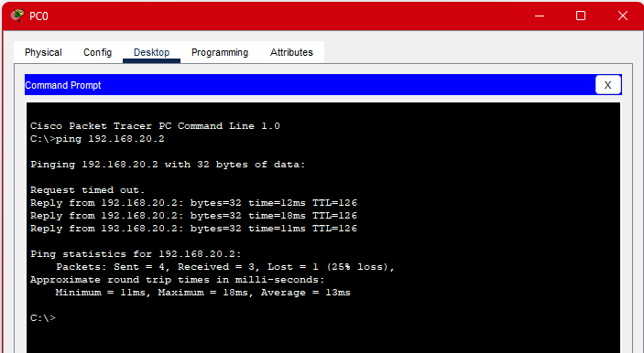

**EXPERIMENT – 10**

**Aim:** To implement the Network Address Resolution (NAT) using Cisco Packet Tracer.

**Theory:**

Network Address Translation (NAT) is a technique used to map private IP addresses to a public IP address to enable communication between devices on a private network and the external public network, typically the internet.

1. Types of NAT:

* Static NAT: Maps a private IP address to a specific public IP address.
* Dynamic NAT: Maps private IP addresses to a pool of public IP addresses.
* PAT (Port Address Translation): Maps multiple private IP addresses to a single public IP address using different port numbers.

2. Components involved:

* Inside Local Address: Private IP addresses used within the internal network.
* Inside Global Address: Public IP address visible to the external network.
* Outside Local Address: IP address as seen from the external network (typically a public IP).
* Outside Global Address: IP address assigned to the device in the external network

**Procedure:**

1. Open Cisco Packet Tracer and create a new project.
2. Drag and drop one switches (type: 2960), 2 Routers (type: 1941).
3. Connect 2 PCs to switch through FastEthernet ports.
4. Connect the switch to the routers. Connect the two routers with cross-connection as shown in figure.
5. Configure IP addresses of all PCs as shown in setup figure. Add default gateway of 192.168.10.1 to all PCs of switch.
6. Open CLI in Router0 and add the following commands to setup it’s IP configurations:

To enter the router

Router>enable

To enter configuration settings

Router#conf t

To edit setting of a specific interface

Router(config)#interface gigabitEthernet 0/1

To change that interface’s IP address and turn “ON” that interface

Router(config-if)#ip add 192.168.10.1 255.255.255.0

Router(config-if)#no shutdown

To end the settings command

Router(config-if)#end

To save the settings to the router

Router#wr

1. Add the similar setting for “gigabitEthernet 0/0” interface with IP address of 10.0.0.1 and subnet mask of 255.255.255.252 (/30).
2. Same steps are to followed for second router to setup its connection:

“gigabitEthernet 0/1” → 10.0.0.2 → 255.255.255.252

1. To add NAT settings to router0:
   1. Open the external interface “gigabitEthernet 0/1” and set the configurations to make external IP address to translate to “Inside”.

Router(config)#interface gigabitEthernet 0/1

Router(config-if)#ip nat inside

Router(config-if)#exit

* 1. Open the external interface “gigabitEthernet 0/0” and set the configurations to make internal IP address to translate to “Outside”.

Router(config)#interface gigabitEthernet 0/0

Router(config-if)#ip nat outside

Router(config-if)#exit

* 1. Set the NAT mapping of Internal Network to External Network using “Static Translation”

Router(config)#ip nat inside source static 192.168.10.10 10.0.0.1

1. Check the connections by pinging the external router (10.0.0.2) through the PC whose translation is submitted to NAT (192.168.10.10).
2. To see the translation table: run command “show ip nat translations” in router.

Project Setup

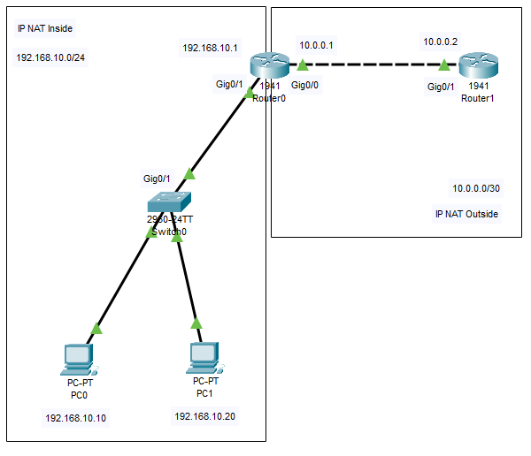

Router0: Setup Configurations

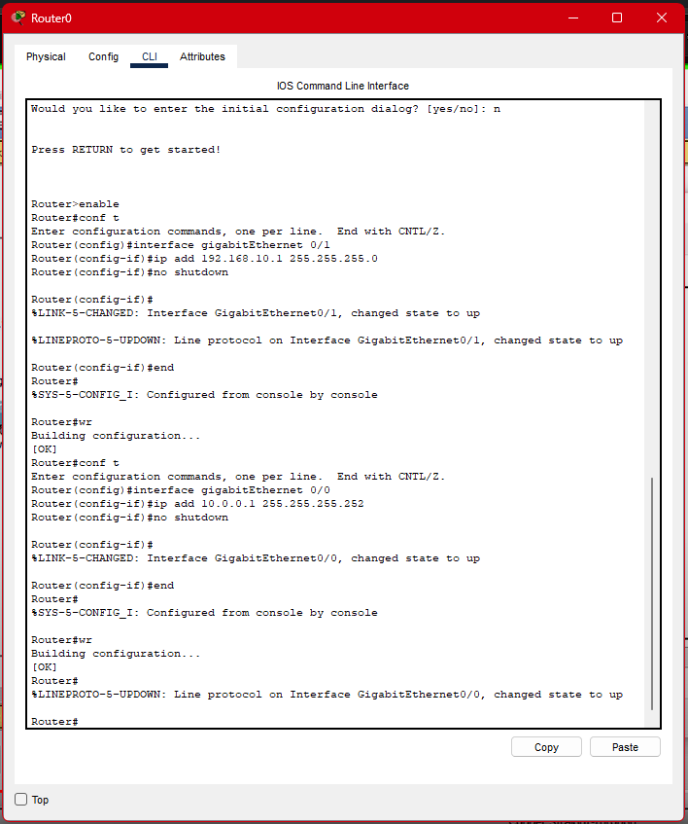

Router1: Setup Configurations

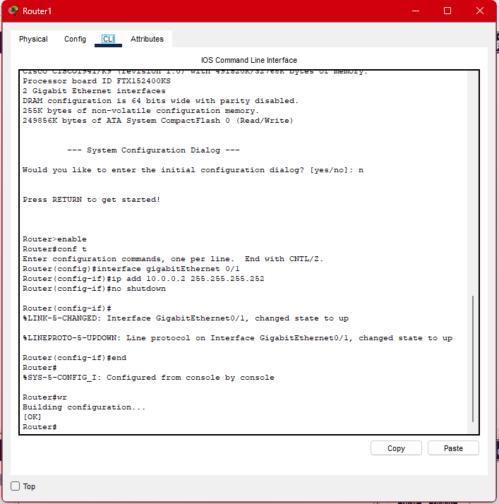

Router0: NAT Configurations

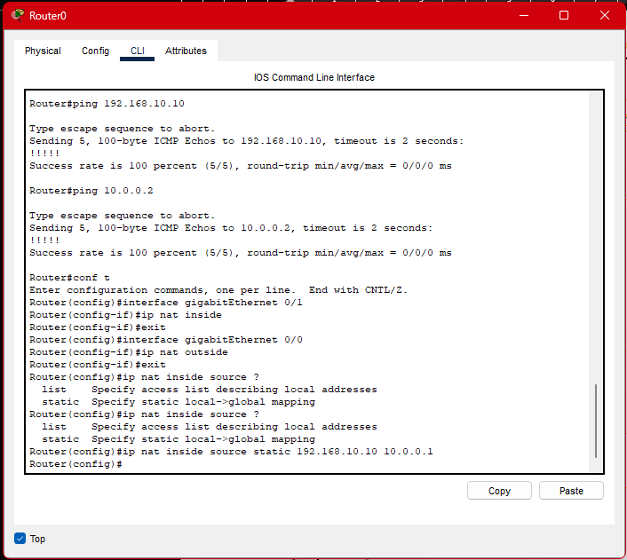

Viewing NAT translations

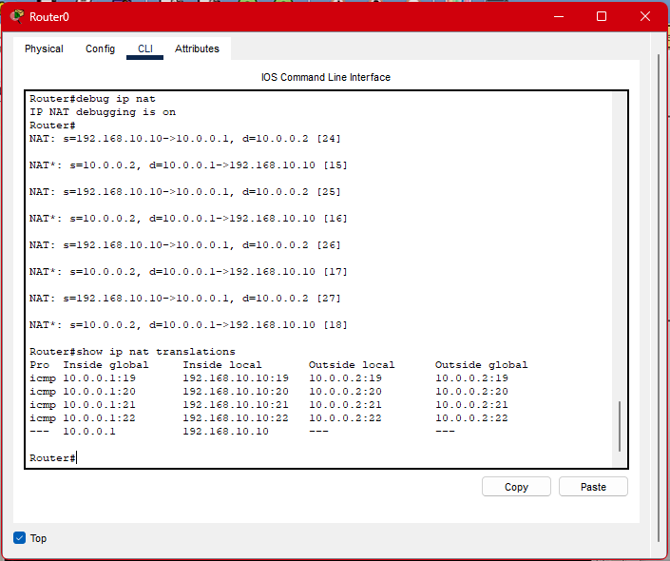

Checking Connections

